**Workout Logger Application**

**Software design document**

**1.Pages Navigation system**

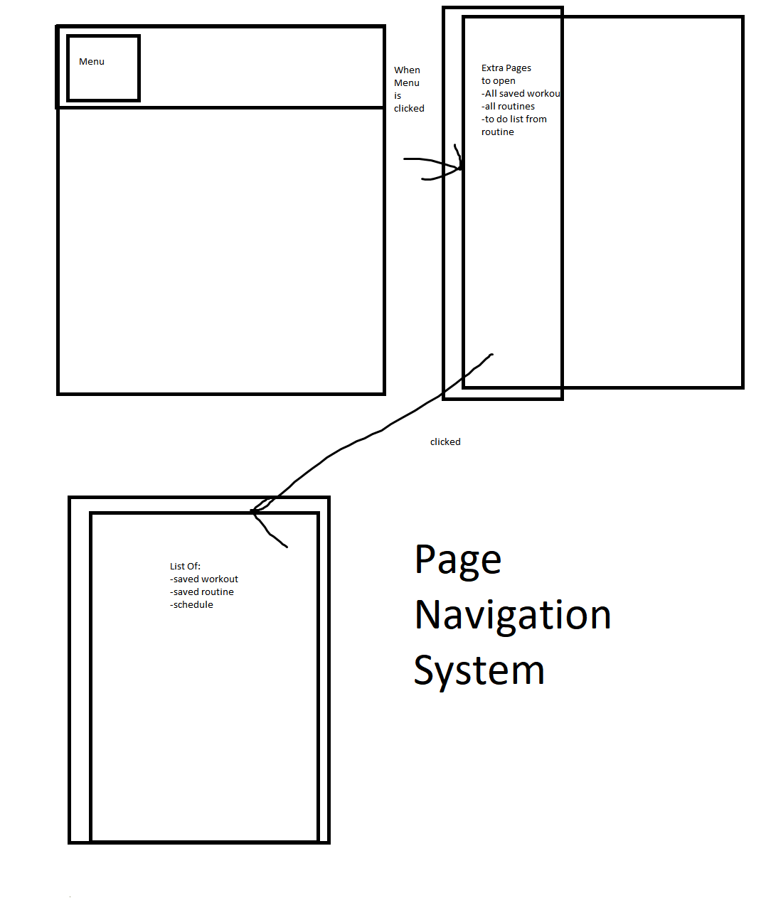

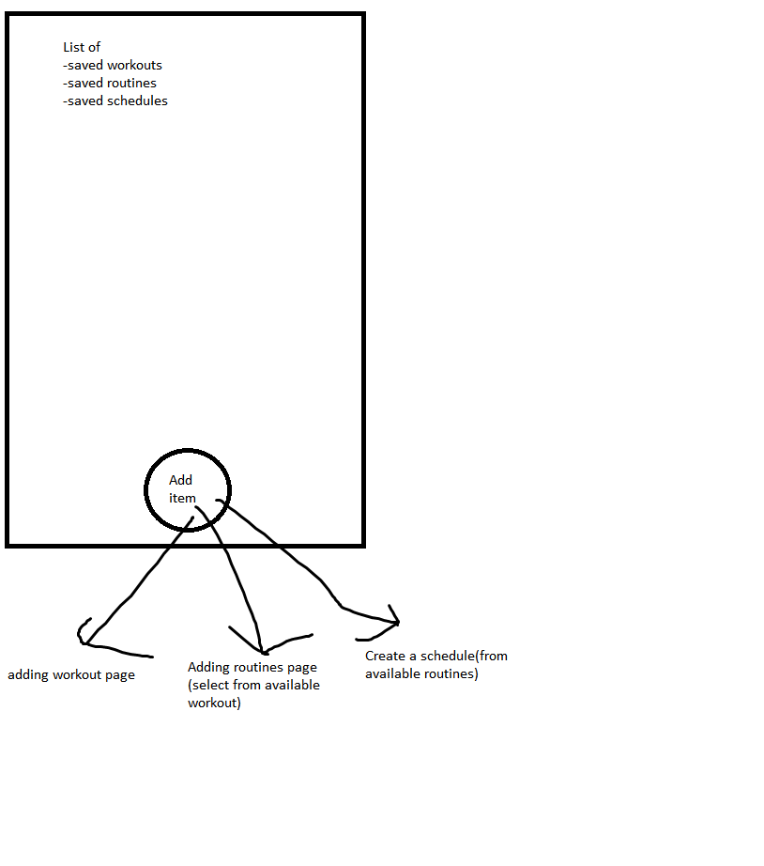**2.Item collection list (splitted into 3 sections)**

**3.Adding item page**

**3.A Adding workout**

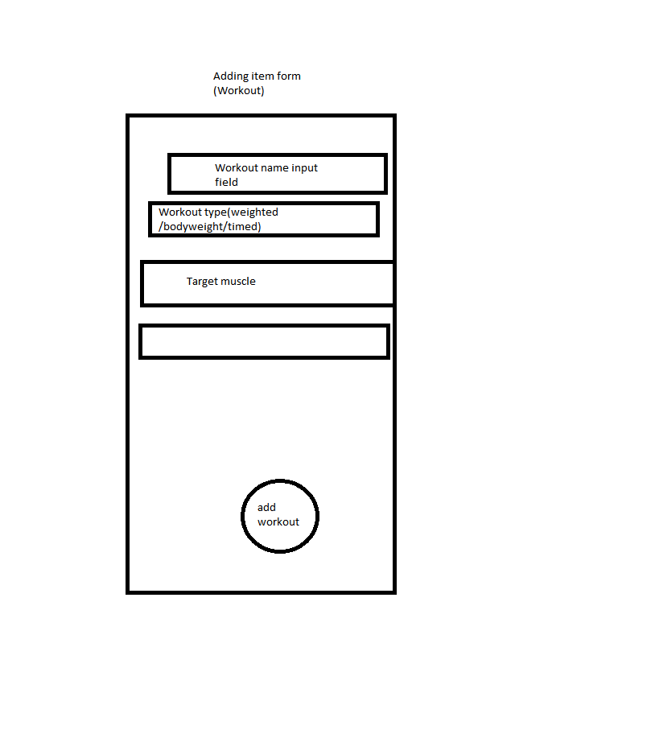

**3.B Adding Routine(collection of workout)**

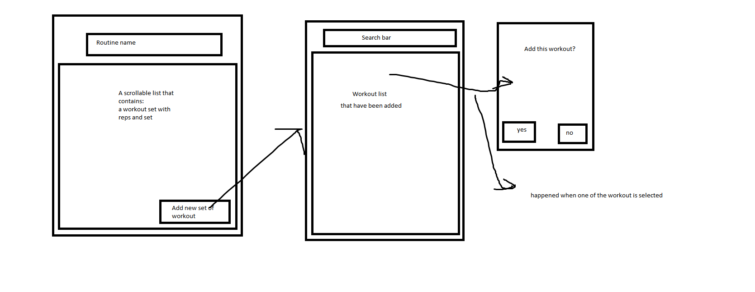

**3.C Adding schedule(add a routine,give it a name and a time)**

